 | 18.3.2 Editors - Graph Editor - Sidebar - Modifiers Tab
Table of content
Detailed table of content 1
Modifiers Tab - Modifiers Panel 4
Modifier header 4
Generator modifier 5
Built- in Function modifier 6
Envelope modifier 8
Cycles modifier 9
Noise modifier 10
Limits modifier 12
Stepped Interpolation modifier 13

Detailed table of content
Detailed table of content
Detailed table of content 1
Modifiers Tab - Modifiers Panel 4
Add Modifier 4
Copy F-Curve Modifiers 4
Paste F-Curve Modifiers 4
Last Operator Add F-Curve Modifier 4
Type 4
Only Active 4
Modifier header 4
Triangle button 4
Active 5
Modifier name 5
Muted 5
Delete F-Curve Modifier 5
Generator modifier 5
Polynomial Mode 5
Additive 5
Order 5
Coefficient 6
x^1 6
Use Influence 6
Influence 6
Restrict Frame Range 6
Start / End 6
Blend In / Out 6
Built- in Function modifier 6
Curve Type 6
Additive 7
Amplitude 7
Phase Multiplier 7
Phase Offset 7
Value Offset 7
Use Influence 7
Influence 7
Restrict Frame Range 7
Start / End 7
In / Out 7
Envelope modifier 8
Envelope 8
Reference Value 8
Min 8
Max 8
Add Control Point 8
Use Influence 8
Influence 8
Restrict Frame Range 8
Start / End 9
In / Out 9
Cycles modifier 9
Trivially Cyclic Curves 9
Before Mode 9
Count 9
After Mode 9
Count 9
Use Influence 10
Influence 10
Restrict Frame Range 10
Start / End 10
In / Out 10
Noise modifier 10
Blend Type 10
Scale 10
Strength 10
Offset 11
Phase 11
Depth 11
Legacy Noise 11
Lacunarity 11
Roughness 11
Use Influence 11
Influence 11
Restrict Frame Range 11
Start / End 11
In / Out 11
Limits modifier 12
Minimum / Maximum X 12
Minimum / Maximum Y 12
Use Influence 12
Influence 12
Restrict Frame Range 12
Start / End 12
In / Out 12
Stepped Interpolation modifier 13
Step Size 13
Offset 13
Start Frame 13
End Frame 13
Use Influence 13
Influence 13
Restrict Frame Range 13
Start / End 13
In / Out 13

Modifiers Tab - Modifiers Panel

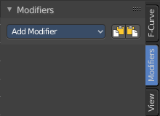
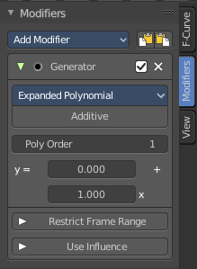
F-Curve modifiers are similar to Object modifiers. They allow to add adjustable non destructive effects. And they can be layered on top of each other.
Different to the Object modifiers you can't reorder this modifiers. You have to create it in the order that you need it.

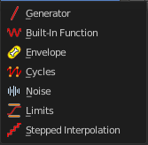
Add Modifier
The list of modifiers. Choose by clicking.

Copy F-Curve Modifiers
Copy the F-Curve Modifiers of the active F-Curve.

Paste F-Curve Modifiers
Paste copied F-Curve modifiers to the active F-Curve.

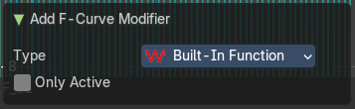
Last Operator Add F-Curve Modifier

Type
A drop down list with the Type of modifier to add.

Only Active
Only add a modifier to the currently active curve.

Modifier header

Every modifier is a panel. And every panel has a header area with some general UI elements.

Triangle button
Every modifier panel can be expanded or collapsed by clicking at this triangle button.

Active
This is the panel that you currently edit. When you edit a panel while it is not set to the active one, then the changes will not be applied.

Modifier name
The name of the modifier. Read only.

Muted
Enable or disable this modifier.

Delete F-Curve Modifier
Delete this modifier.

Generator modifier
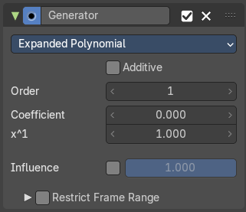

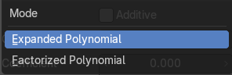
Polynomial Mode
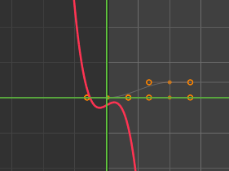
Use Expanded Polynominal or Factorized Polynominal algorithm. With these mathematical formulas you can create lines, parabolas, and other more complex curves by changing the values in the poly order field.

Additive
Add on top of the existing curve instead of replacing the existing curve.

Order
The hightes value of X for this polynominal.

Coefficient
Coefficient for X.

x^1
Coefficient for X.

Use Influence
Temper the F-Curve Modifier effect by a default influence factor.
Expanding the Use Influence sets it to active. It reveals a value slider then.

Influence
The influence factor.

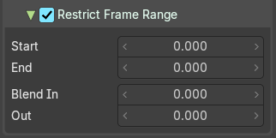
Restrict Frame Range
Expanding the Restrict Frame range sets it to active. It reveals some value slider then.

Start / End
The start and end frame of the generated curve.

Blend In / Out
Fade the curve in or out for chosen frame numbers.

Built- in Function modifier

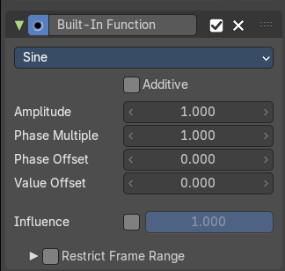
Generate a curve by built in functions.
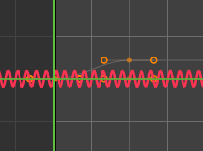

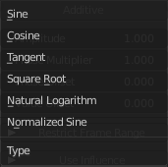
Curve Type
The available wave forms for the curve.

Additive
Add on top of the existing curve instead of replacing the existing curve.

Amplitude
The amplitude of the curve wave. Adjusts the Y scaling.

Phase Multiplier
A phase multiplier for the curve wave. Adjusts the X scaling.

Phase Offset
A phase offset for the curve wave. Adjusts the Y scaling.

Value Offset
A constant value offset for the whole curve. Adjusts the X scaling.

Use Influence
Temper the F-Curve Modifier effect by a default influence factor.
Expanding the Use Influence sets it to active. It reveals a value slider then.

Influence
The influence factor.

Restrict Frame Range
Expanding the Restrict Frame range sets it to active. It reveals some value slider then.

Start / End
The start and end frame of the generated curve.

In / Out
Fade the curve in or out for chosen frame numbers.

Envelope modifier
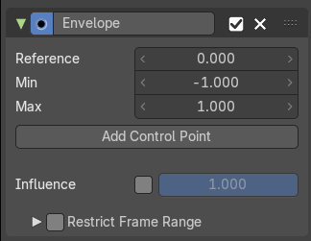
The Envelope modifier allows you to modify the overall shape of the curve by control points.
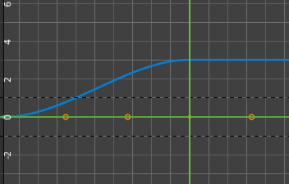
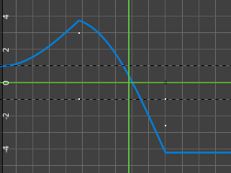

Envelope

Reference Value
Set the Y value to center the envelope around.

Min
The lower distance from reference value for 1:1 default influence.

Max
The higher distance from reference value for 1:1 default influence.

Add Control Point
Add a control point. A control point has two sub points, a lower control point and a higher control point.

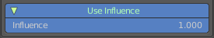
Use Influence
Temper the F-Curve Modifier effect by a default influence factor.
Expanding the Use Influence sets it to active. It reveals a value slider then.

Influence
The influence factor.

Restrict Frame Range
Expanding the Restrict Frame range sets it to active. It reveals some value slider then.

Start / End
The start and end frame of the generated curve.

In / Out
Fade the curve in or out for chosen frame numbers.

Cycles modifier
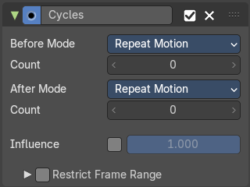
Add a cyclic motion to a curve that has two or more control points. The option can be set before or after the curve.

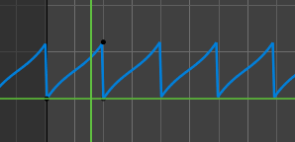
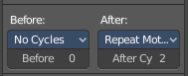
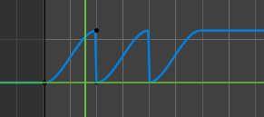

Trivially Cyclic Curves
When the Cycle Mode for both ends is set to either Repeat Motion or Repeat with Offset, and no other options of the modifier are changed from their defaults, it defines a simple infinite cycle.
This special case receives some additional support from other areas of Blender:
Automatic Bezier handle placement is aware of the cycle and adjusts to achieve a smooth transition.
The Cycle-Aware Keying option can be enabled to take the cycle into account when inserting new keyframes.

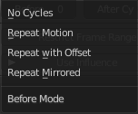
Before Mode
Set the cycle mode before the first keyframe.

Count
Maximum number of cycles to allow before first keyframes. A value of 0 means infinite.

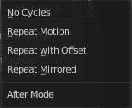
After Mode
Set the cycle mode after the first keyframe.

Count
Maximum number of cycles to allow after last keyframes. A value of 0 means infinite.

Use Influence
Temper the F-Curve Modifier effect by a default influence factor.
Expanding the Use Influence sets it to active. It reveals a value slider then.

Influence
The influence factor.

Restrict Frame Range
Expanding the Restrict Frame range sets it to active. It reveals some value slider then.

Start / End
The start and end frame of the generated curve.

In / Out
Fade the curve in or out for chosen frame numbers.

Noise modifier
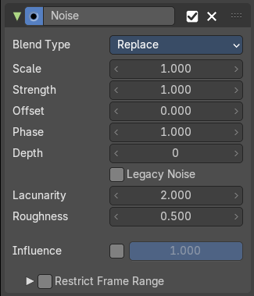
Adds noise to the curve.

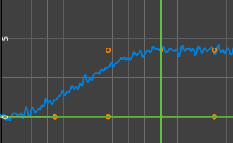

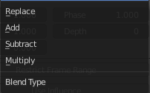
Blend Type
How to blend the noise with the curve.

Scale
The overall size of the noise. The bigger the value the less frequent the noise.

Strength
Adjust the Y value of the noise.

Offset
Time offset of the noise.

Phase
The random seed for the noise.

Depth
How detailed the noise function is.

Legacy Noise
Use the legacy way of generating noise.

Lacunarity
Gap between successive frequencies. A value of 0 disables the feature.

Roughness
Amount of high frequency details.

Use Influence
Temper the F-Curve Modifier effect by a default influence factor.
Expanding the Use Influence sets it to active. It reveals a value slider then.

Influence
The influence factor.

Restrict Frame Range
Expanding the Restrict Frame range sets it to active. It reveals some value slider then.

Start / End
The start and end frame of the generated curve.

In / Out
Fade the curve in or out for chosen frame numbers.

Limits modifier

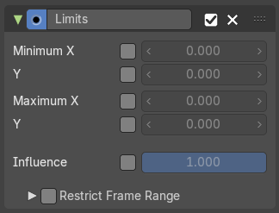
Sets limits to the curve in specified x and y range values.

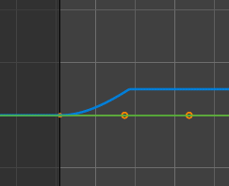

Minimum / Maximum X
Cuts the curve at these minimum and maximum frame values.

Minimum / Maximum Y
Clamps the curve at these minimum and maximum values.

Use Influence
Temper the F-Curve Modifier effect by a default influence factor.
Expanding the Use Influence sets it to active. It reveals a value slider then.

Influence
The influence factor.

Restrict Frame Range
Expanding the Restrict Frame range sets it to active. It reveals some value slider then.

Start / End
The start and end frame of the generated curve.

In / Out
Fade the curve in or out for chosen frame numbers.

Stepped Interpolation modifier

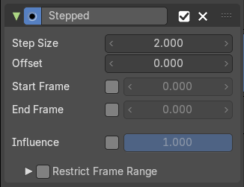
Adds steps to the curve by rounding the values.

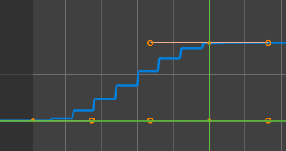

Step Size
The number of frames to hold each frame

Offset
A number of offset frames before frames get held.

Start Frame
Restrict the modifier so that it just acts before its end frame.

End Frame
Restrict the modifier so that it just acts after its start frame.

Use Influence
Temper the F-Curve Modifier effect by a default influence factor.
Expanding the Use Influence sets it to active. It reveals a value slider then.

Influence
The influence factor.

Restrict Frame Range
Expanding the Restrict Frame range sets it to active. It reveals some value slider then.

Start / End
The start and end frame of the generated curve.

In / Out
Fade the curve in or out for chosen frame numbers.

